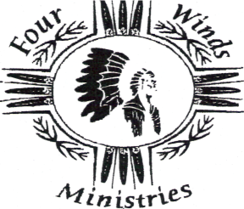
FALL 2009
OUR MISSION STATEMENT
The mission of the Montana Native American Ministries and the Four Winds Ministry Center is to offer a higher purpose for living and equip lives by giving hope and an expected end through Jesus Christ. To assist the Native American people in achieving their complete identity in Christ, and be proud of their remarkable history and who they are.
“There Is No God Like Our God”

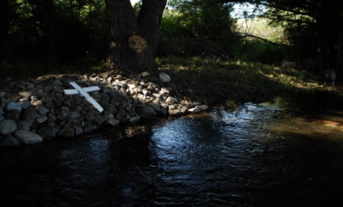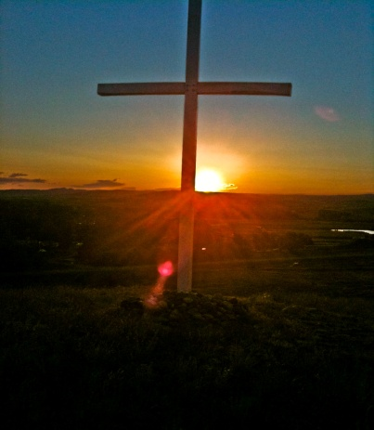
Once again, we are giving thanks to our supporters and partners who are joining with us to make everything you see in this newsletter a reality and a success. This summer was full of work-groups, youth camps and visitors from all over the United States. Groups and visitors came from Alabama, Louisiana, North and South Carolina, Georgia, Tennessee, Florida, Illinois, Virginia, and South Dakota. We consider it an honor to be part of God’s work in this place, with camp results being: 18 youth saved, 9 rededications to the LORD and 26 water baptisms. TO GOD BE THE GLORY!
“I can only say that when I arrived for camp I never thought that the Lord would exceed my expectations for the week of services. It was an incredible experience to work once again with the leaders and counselors from Asbury Methodist Church from Birmingham, Alabama. There was no shortage of love for the campers who came to be a part of this year’s camp. During the services, the Lord did many wonderful works as these young people opened up their heart for Christ; however, the highlight for me was the water baptism service on Friday where we baptized 26 campers. I truly believe that the Lord dealt with hurts and wounds in some of these young lives and revolutionized their hearts. I thank God for people like Ron and Kathy Countryman who sacrifice so much for the work of Jesus Christ. I am grateful for the opportunity to have a small part of this ministry as a speaker and pray that our fruit will be eternal.” ~Evangelist Nick McSpadden

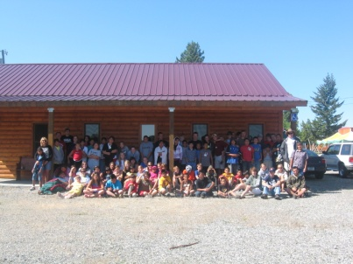
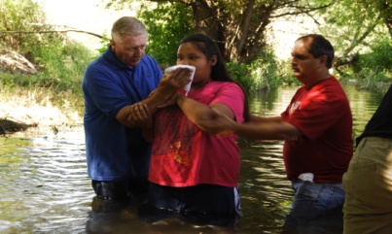
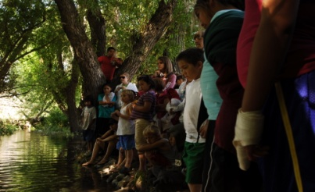
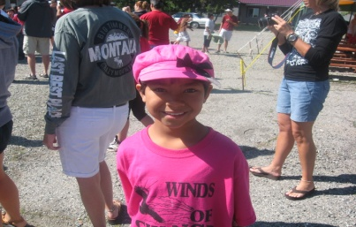
Our 2010 Calendar is already beginning to fill up, so if you or your mission’s team is interested in working/ministering at Four Winds, please contact us as soon as possible. We desperately need clean-up groups for both the spring and fall. We have 24 acres and 10+ buildings. We look forward to hearing from you! God bless!
(406) 932-4224
“Four Winds Ministry is not only beautiful because of God's beauty in the Earth He has created but also it is equally beautiful to see the transformation of His peoples' hearts that occurs there. It is such a blessing to be part of a ministry that is directly ministering to Native Amercians... more of the Lord's precious people. I look forward to returning to Four Winds to once again serve my Father by serving His people.”
Jon Brennan
Youth Worship Leader
Birmingham, AL
The following before and after pictures showcase a typical workweek at Four Winds:
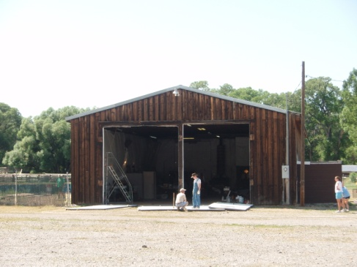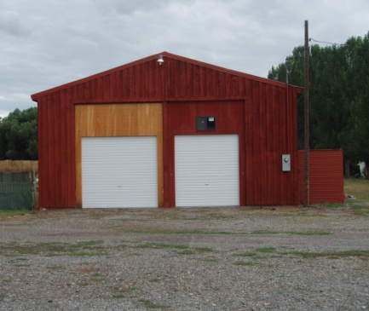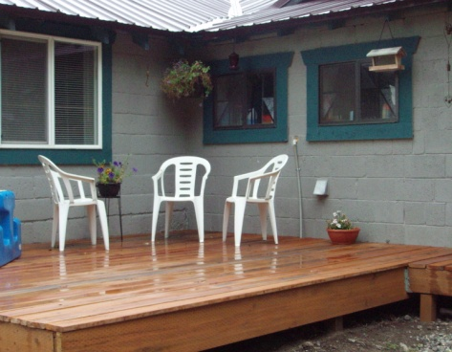
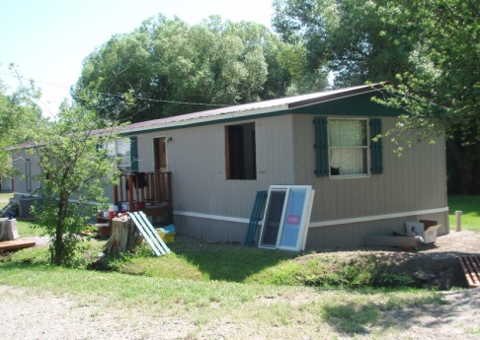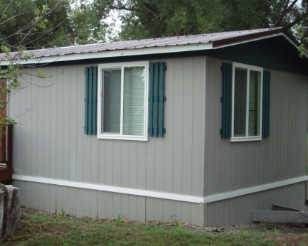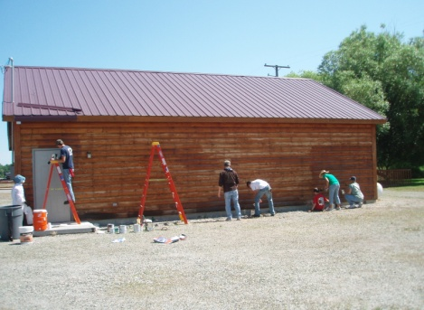

Prioritized Needs List:
- Office with Equipment & Furnishings
- Bath/Shower House
- Monthly Support for Staff
- Funds for Winter Utilities
- Sponsors and Staff for Youth Camps
- Utility Tractor
- Riding Lawnmower
- Sprinkler System & New Sod/Asphalt
Always Needed: Donations for Food & New Clothing for Reservation Children
Please, if you have a group interested in helping, contact ASAP!

“We wish to thank Ron & Kathy, Kim and Justin Countryman for a wonderful visit to Four Winds Ministry in Big Timber, MT. The Countryman’s are God’s messengers to those who will listen. No one knows their sacrifices, or the depth of their love for the Native Americans, but God Himself. It is a wonderful honor and privilege to always visit them here. If there were more people like them, this world would be a much better place to live. They truly are one of the best parts we’ve ever known.”
~ Dr. Tom Swartz, Indian Ministry North America, Blairsville, GA
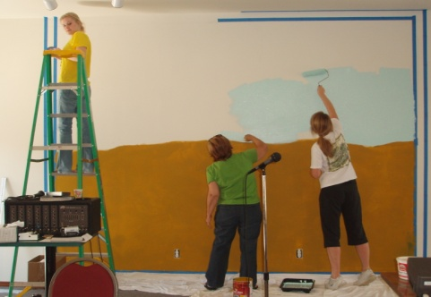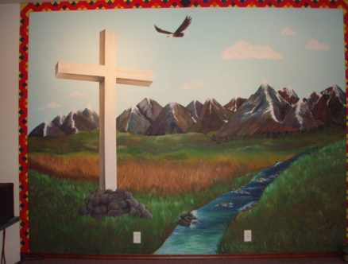
“Over the past 6 years of doing projects at the youth camp, of which I feel is part of my calling, is to see and hear of the young people that have given their heart to God and to know I have been a small part of that! What an awesome God! Praise the Lord! Thanks Ron and Kathy and the whole Four Winds team for letting me be a small part of the ministry.”
Steve Wallace,
Director MissioNails
Chelsea, AL

Staff & Group Pictures
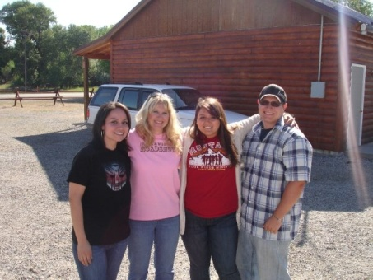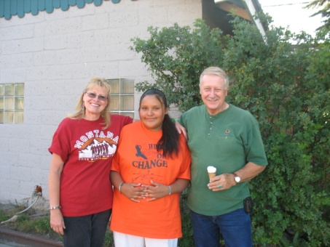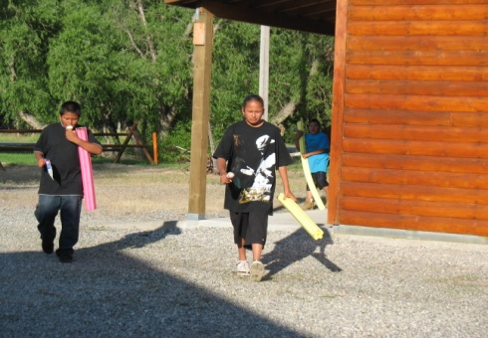
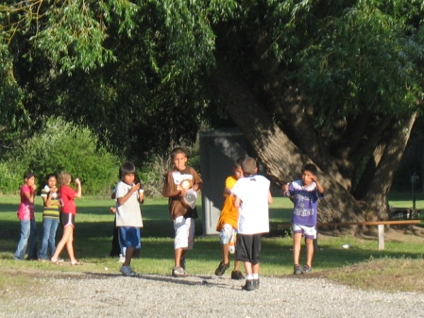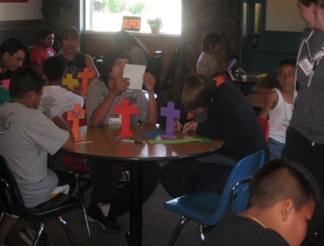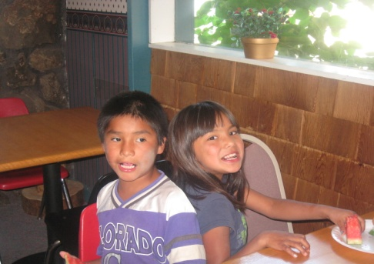
Reflections from the Director’s Desk
“I have been young, and now am old; yet have I not seen the righteous forsaken, nor his seed begging bread.” Psalm 37:25
“Early yesterday morning during my devotion, I once again read this wonderful Scripture. As I sat in our “upper room” listening to the birds sing and feeling the cool breeze through the open window, my mind drifted back to September of 1975 and our journey to the great state of Montana. September of this year begins our 35th year of ministering to the Native Americans of this state. As I reflect back to the meager beginning of our efforts to make contacts and inroads, travelling to the seven reservations, to now having a ministry center that they come to. Four Winds Ministry Center provides camps, Biblical training, and times of spiritual refreshing for the Native American people. Because of your generosity, we are able to deliver food, blankets, and new clothing for the crucial winter months, as well as supplying backpacks, school supplies, Bibles and Sunday school materials. Space and time prevent me from relaying to you the reality of our vision and lifelong dream coming to fruition.”
~ Ron Countryman ~

CONTACT INFORMATION

FOUR WINDS MINISTRY CENTER:
KIM: 406-932-4224 kim_4winds@yahoo.com
JUSTIN: 406-930-0497
MNAM: 406-932-4226
RON & KATHY COUNTRYMAN
PO BOX 1116
BIG TIMBER, MT 59011

